Data Sheet
Product Information
Product Name | : | Recombinant Human Connective Tissue Growth Factor (rhCTGF)
Synonyms | : | CTGF, CCN2, HCS24, IGFBP8, NOV2
Description | : | CTGF is a matricellular protein of the CCN family of extracellular matrix-associated heparin-binding proteins. CTGF has important roles in many biological processes, including cell adhesion, migration, proliferation, angiogenesis, skeletal development, and tissue wound repair, and is critically involved in fibrotic disease and several forms of cancers. CTGF is also important for pancreatic beta cell development, and is critical for normal ovarian follicle development and ovulation. CTGF is associated with wound healing and virtually all fibrotic pathology. It is thought that CTGF can cooperate with TGF-β to induce sustained fibrosis and to exacerbate extracellular matrix production in association other fibrosis-inducing conditions. (Ref. From Wikipedia)
NCBI Accession No. | : | NM_001901.2
Amino acid sequence | : | MGKKCIRTPKISKPIKFELSGCTSMKTYRAKFCGVCTDGRCCTPHRTTTLPVEFKCPDGEVMKKNMMFIKTCACHYNCPGDNDIFESLYYRKMYGDMA*
Molecular Mass | : | 11.17kDa (98 aa)
Protein Tags | : | No tagging
Source | : | E. coli.
Cat. No. | : | JW-H028-0010, JW-H028-0025, JW-H028-0100, JW-H028-0250, JW-H028-0500, JW-H028-1000
Storage | : | Should be at ≤ -70 ℃ as undiluted aliquots of handy size. Avoid repeated freezing and thawing.
Cross Reactivity | : | Human, Mouse, Rat, Chicken

Quality Control
Test items |  |  |  | Specifications
Appearance |  |  | : |  | Clear, colorless liquid
Purity |  |  | : |  | Greater than 95 % by RP-HPLC and SDS-PAGE
Specificity |  |  | : |  | Using Western blot, detection | 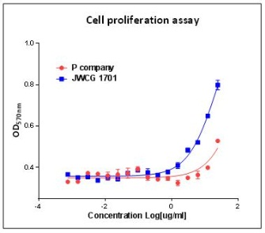
Concentration |  |  | : |  | 0.1 mg/㎖, Bradford method
Biological Activity |  |  | : |  | Determined by proliferation of HUVEC indicator cells.  The ED50 is 1.0 ~ 2.0 ug/ml.
Endotoxin |  |  | : |  | Less than 0.2 EU/㎍ as determined by the LAL method
Formulation |  |  | : |  | 50mM Sodium citrate-citric acid, 5% Glycerol (pH 4.5) without preservative or carrier proteins.
Stability |  |  | : |  | Stable for up to 12 months at -70 ℃. Stable for a month at 4 ℃.
Sterility |  |  | : |  | Sterilized through a 0.2 ㎛ membrane filter and packaged aseptically. Culture for 2 weeks, no growth

